

**Team Members**

|  |  |
| --- | --- |
| Name | id |
| mahmoud essam | 20221460231 |
| abdelrhman ashraf | 20221374041 |
| abdullah hussien | 20221427861 |
| mazen tantway | 20221321744 |
| elfares Howera | 210101072 |

**Computer Network Project**

**FCDS Case Study**

**Supervised by**

**Eng. Muhammed Hatem**

# **Computer Network Project**

**Case Study New Building of FCDS**

# **1.Project’s Structure**

|  |  |
| --- | --- |
| Structure | Topology Used |
| Whole project | **Star** |
| Data Science Dep | **Ring** |
| AI Dep | **Partially connected** |
| Media Dep | **Bus** |
| Business | **Tree** |
| Cybersecurity | **Tree** |

|  |  |  |  |
| --- | --- | --- | --- |
| Structure | # of Routers | # of Switches | # of PCs |
| Whole project | **8** | **34** | **68 as prototype** |
| Data Science Dep | **1** | **8** | **16** |
| AI Dep | **1** | **7** | **14** |
| Media Dep | **1** | **5** | **10** |
| Business | **1** | **7** | **14** |
| Cybersecurity | **1** | **7** | **14** |
| Backbone Router | **1** | **X** | **X** |
| General Router | **1** | **X** | **X** |
| Special Router | **1** | **X** | **X** |

**Department’s internal structure: -**

**Basic details**

**After the construction of the project was done, we made 3 copies of the project, to apply different types of routing techniques, while applying NAT to save private IPs and also making the consumption of the internal IPs much lesser, and finally we applied Security to save Servers from any unknown Actions.**

**Contents:**

**1.Performing Subnetting**

**2.Performing Nat for internal Security and saving IP’S**

**3.Simple Routing (EIGRP – RIP – OSPF)**

**4.Some Security to save servers**

**5.Some Bonus!**

# **2.Subnetting Step**

**Subnetting steps just to show the importance of saving the cost of buying a million IP’s.**

**What’s the main IP for this case study?**

**For All Departments, we have found our departments.**

|  |  |
| --- | --- |
| **Department** | **Number** |
| **Data Science** | **212** |
| **AI** | **47** |
| **Cyber Security** | **36** |
| **Business** | **125** |
| **Media** | **10** |
| **Total** | **430** |

**So, by supplying 193.158.1.0 for DS is enough for it.**

**Giving Ai and CS with Media to 193.158.2.0**

**And setting 193.158.3.0 Business to fit all data on.**

**_____________________________________________________________________________________________**

**This step will show the subnetting for Each Department**

1. **Data Science**

|  |  |
| --- | --- |
| **Subnetwork** | **255.255.255.0** |
| **Network** | **193.158.1.0** |
| **Broadcast** | **193.158.1.255** |
| **Usable Range for Ips** | **193.158.1.1 to 193.158.1.254** |
| **Number of Needed** | **212** |
| **Number of Usable** | **254** |
| **Achieved Requirements** | **Yes** |

1. **Business**

|  |  |
| --- | --- |
| **Subnetwork** | **255.255.255.128** |
| **Network** | **193.158.3.0** |
| **Broadcast** | **193.158.3.127** |
| **Usable Range for Ips** | **193.158.3.1 to 193.158.3.126** |
| **Number of Needed** | **126** |
| **Number of Usable** | **128** |
| **Achieved Requirements** | **Yes** |

**Subnetting Steps Next**

1. **Media**

|  |  |
| --- | --- |
| **Subnetwork** | **255.255.255.240** |
| **Network** | **193.158.2.0** |
| **Broadcast** | **193.158.2.15** |
| **Usable Range for Ips** | **193.158.2.1 to 193.158.2.14** |
| **Number of Needed** | **14** |
| **Number of Usable** | **16** |
| **Achieved Requirements** | **Yes** |

1. **AI**

|  |  |
| --- | --- |
| **Subnetwork** | **255.255.255.192** |
| **Network** | **193.158.2.64** |
| **Broadcast** | **193.158.2.127** |
| **Usable Range for Ips** | **193.158.2.65 to 193.158.2.126** |
| **Number of Needed** | **47** |
| **Number of Usable** | **64** |
| **Achieved Requirements** | **Yes** |

1. **Cybersecurity**

|  |  |
| --- | --- |
| **Subnetwork** | **255.255.255.192** |
| **Network** | **193.158.2.128** |
| **Broadcast** | **193.158.2.191** |
| **Usable Range for Ips** | **193.158.2.129 to 193.158.2.190** |
| **Number of Needed** | **36** |
| **Number of Usable** | **64** |
| **Achieved Requirements** | **Yes** |

1. **Server for General**

|  |  |
| --- | --- |
| **Subnetwork** | **255.255.0.0** |
| **Network** | **172.125.0.0** |
| **Broadcast** | **172.125.255.255** |
| **Needed IP Ranges Only** | **172.125.12.9 - 172.125.12.10** |
| **Number of Needed** | **2** |
| **Achieved Requirements** | **Yes** |

1. **Server for Special**

|  |  |
| --- | --- |
| **Subnetwork** | **255.255.0.0** |
| **Network** | **174.125.0.0** |
| **Broadcast** | **174.125.255.255** |
| **Needed IP Ranges Only** | **174.125.12.9 - 174.125.12.10** |
| **Number of Needed** | **2** |
| **Achieved Requirements** | **Yes** |

1. **Serials**

|  |  |
| --- | --- |
| **Subnetwork** | **255.255.255.252** |
| **Main IP Network** | **10.0.0.0** |

1. **Backbone and Data Science**

|  |  |
| --- | --- |
| **Subnetwork** | **255.255.255.252** |
| **Main IP Network** | **10.0.0.0** |
| **First IP** | **10.0.0.1** |
| **Second IP** | **10.0.0.2** |
| **Broadcast** | **10.0.0.3** |

1. **Backbone and AI**

|  |  |
| --- | --- |
| **Subnetwork** | **255.255.255.252** |
| **Main IP Network** | **10.0.0.4** |
| **First IP** | **10.0.0.5** |
| **Second IP** | **10.0.0.6** |
| **Broadcast** | **10.0.0.7** |

1. **Backbone and CS**

|  |  |
| --- | --- |
| **Subnetwork** | **255.255.255.252** |
| **Main IP Network** | **10.0.0.8** |
| **First IP** | **10.0.0.9** |
| **Second IP** | **10.0.0.10** |
| **Broadcast** | **10.0.0.11** |

1. **Backbone and Business**

|  |  |
| --- | --- |
| **Subnetwork** | **255.255.255.252** |
| **Main IP Network** | **10.0.0.12** |
| **First IP** | **10.0.0.13** |
| **Second IP** | **10.0.0.14** |
| **Broadcast** | **10.0.0.15** |

1. **Backbone and Media**

|  |  |
| --- | --- |
| **Subnetwork** | **255.255.255.252** |
| **Main IP Network** | **10.0.0.16** |
| **First IP** | **10.0.0.17** |
| **Second IP** | **10.0.0.18** |
| **Broadcast** | **10.0.0.19** |

1. **Backbone For General and Special**

|  |  |
| --- | --- |
| **Subnetwork** | **255.255.255.252** |
| **Main IP Network** | **10.0.0.20 – 10.0.0.24** |
| **First IP** | **10.0.0.21 – 10.0.0.25** |
| **Second IP** | **10.0.0.22 – 10.0.0.26** |
| **Broadcast** | **10.0.0.23 – 10.0.0.27** |

# **3.Routing Steps**

**Routing is the process of path selection in any network.**

* **Each routing technique is applied in a unique copy of the project, to make sure each technique is working independently.**

**As explained in the project introduction, we used 3 types of routing techniques: -**

1. **OSPF (Open Shortest Path First)**

* **Builds a complete map of the network topology and shares it with all routers in the same area.**
* **Configuration code for the OSPF: -**

1. **router ospf (process ID)**
2. **network (Network IP) (Wild mask) area #**
3. **network (Serial IP) (Wild mask) area #**
4. **EIGRP (Enhanced Interior Gateway Routing Protocol)**

* **EIGRP sends partial updates to neighbors only when there is a change in the network topology.**
* **EIGRP has a fast convergence time due to its partial updates and Diffusing Update Algorithm (DUAL).**
* **Configuration code for the EIGRP:-**

1. **router eigrp (process ID)**
2. **network (Network IP) (Wild mask)**
3. **network (Serial IP) (Wild mask)**
4. **RIP (Routing Information Protocol)**

* **Is a distance-vector routing protocol that uses hop count as its metric.**
* **Has a slow convergence time due to its periodic updates and count-to-infinity problem.**
* **Configuration code for the RIP: -**

1. **router rip (process ID)**
2. **network (Network IP)**
3. **network (Serial IP)**

|  |  |  |  |  |
| --- | --- | --- | --- | --- |
| Protocol | Type | Metric | Convergence Time | Complexity |
| RIP | Distance-Vector | Hop count | Slow | Low |
| OSPF | Link-state | Multiple | Fast | High |
| EIGRP | Hybrid | Composite | Fast | Medium |

# **4.NAT Steps**

**There are 3 types of NAT-TING.**

1. **Static NAT**
2. **Dynamic NAT**
3. **PAT**

**Why NAT-TING?**

1. **Legally registered IP addresses are preserved by NAT.**
2. **The IP address of the device transmitting and receiving communication is concealed.**
3. **Removes the need for address renumbering as the network changes.**
4. **Static NAT**

* **Using static NAT, internal private IP addresses can be translated into static public IP addresses, allowing for reliable one-to-one mapping of incoming and outgoing traffic.**

**Static NAT code:**

**ip nat inside source static <local_ip> <global_ip>**

1. **Dynamic NAT**

* **Several private IP addresses are translated to a pool of public IP addresses in this kind of NAT. It is used when we are aware of the total number of fixed users wishing to connect to the Internet at any moment.**

**Dynamic NAT code:**

**ip nat pool POOL_TEST <Pool beginning> <Pool ending> netmask <Subnet Mask>**

**ip nat inside source list <access_list> <interface>**

1. **PAT (Port Address Translation)**

* **In PAT, Private IP addresses are translated into the public IP address via Port numbers.**
* **PAT also uses IPv4 address but with a port number.**

**PAT code:**

**access-list <#> permit <ip address> <wild mask>**

**ip nat inside source list <access_list> <interface> overload**

# **5.Security Steps**

**After performing all these tasks, we need to secure our server that there’s no device in other department could access server if this server not required to response for this device.**

**So, we need to perform something called Access-List as it can differentiate IP traffic.**

**Syntax of our Access-list:**

**Router(config)# access-list “ID Process” Deny “Required to Deny” “Netmask” Router(config)# access-list “ID Process” Permit Any**

**Router(config)# int needed Serial.**

**Router(config-if)# ip access-group “Same ID Process”**

**_____________________________________________________________________________________________**

**Last Thing, Main Final Topology!**

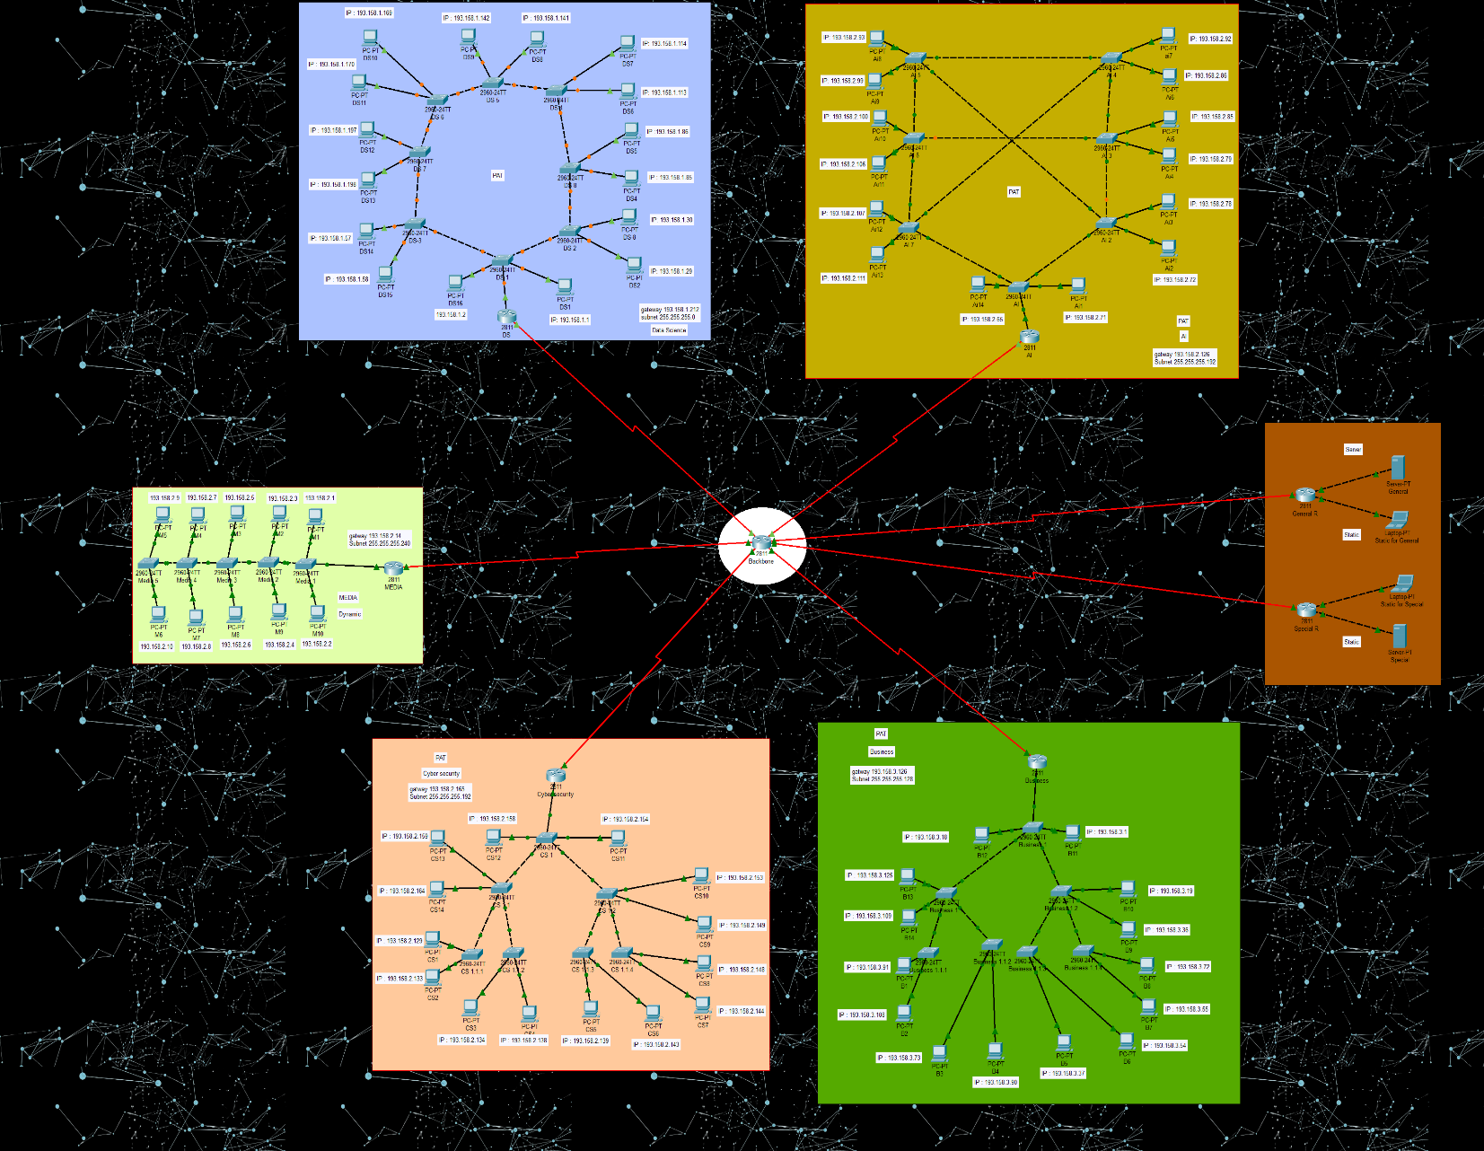

# **6.Additional Points**

**Work Done :**

1. **NTP ( Network Time Protocol ) :-**

* **A protocol that allows the synchronization of system clocks.**
* **Server🡪NTP🡪Adjust time.**

1. **DNS ( Domain Name System ) :-**

* **Access the IP through domain names.**
* **Changes internal IP into domain name**

1. **FTP ( File Transfer Protocol ) :-**

* **Used for the transfer of files from one host to another over a TCP-based network.**
* **Server🡪FTP🡪Enable authentication🡪Apply username, pass and permissions.**

1. **SSH ( Secure Socket Shell )**

* **Gives users, particularly system administrators, a secure way to access a computer over an unsecured network.**
* **Configuration code for the SSH: -**

1. **Set the IP domain name to "SSH1" and hostname to "Department name."**
2. **Initiated RSA key generation with a modulus of 1024 bits.**
3. **Configured lines 0 to 15 for SSH access with local login and set the SSH**

**protocol to v2.**

1. **And finally added a local user with full privileges.**
2. **Telnet( Teletype Network )**

* **Provides access to virtual terminals of remote systems on local area networks or the Internet.**
* **Configuration code for the Telnet : -**

1. **Assign the Router IP address alongside it’s subnet mask to**

**internal interface.**

1. **Configured lines 0 to 5 for Telnet access, set login with a**

**specified password.**

1. **Password**

* **We applied passwords for each router to increase the security.**

1. **Web server**

* **We’ve built up a simple website simulation for each of our departments (General, Special).**